1.Draw a simple diagram showing the pin layout of an RJ-45 connector and label the color codes for the T568A and T568B Ethernet wiring standards.
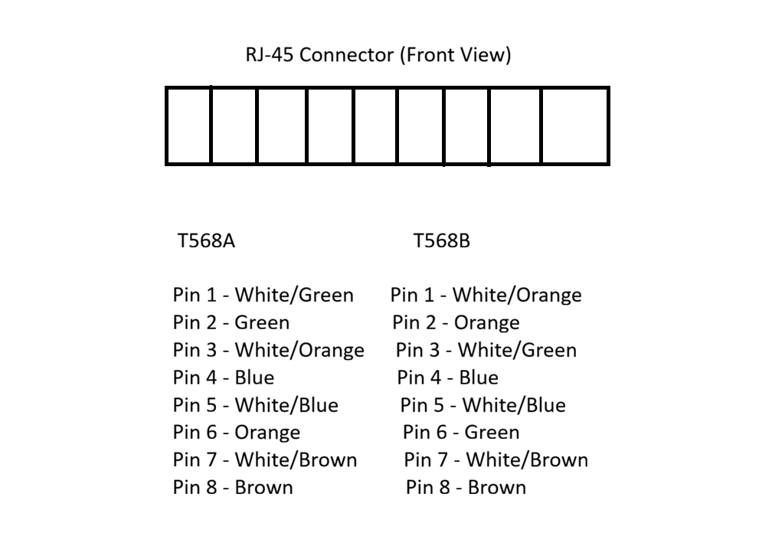
2.Create a table comparing the key specifications of Ethernet standards 10BASE-T, 100BASE-TX, and 1000BASE-T, including speed, cable type, maximum cable length, and connector type.
Ethernet Standard | Speed | Cable Type | Maximum Cable Length | Connector Type
10BASE-T | 10 Mbps | Cat3 or Cat5 UTP | 100 meters | RJ-45
100BASE-TX | 100 Mbps | Cat5 UTP or higher | 100 meters | RJ-45
1000BASE-T | 1000 Mbps (1 Gbps) | Cat5e or Cat6 UTP | 100 meters | RJ-45

3.Given a scenario where you need to connect two laptops directly using Ethernet, explain which cable (straight-through or crossover) you would use and why.<br><br><em><strong>Hint:</strong> Think about how transmit and receive pairs are wired in each cable type.</em>
->If I need to connect two laptops directly using an Ethernet cable, I would use a crossover cable.

Reason:
A crossover cable swaps the transmit (TX) and receive (RX) wire pairs. This allows both laptops to send and receive data correctly without needing a switch or hub between them.

Note:
Most modern laptops support Auto MDI-X, so they can also work with a straight-through cable. However, according to standard networking concepts, the correct answer is crossover cable for a direct laptop-to-laptop connection.
4.List three real-world devices in your home or college that use Ethernet connections, and for each, specify the likely Ethernet standard (e.g., 100BASE-TX, 1000BASE-T) they support.
fDevice | Location | Likely Ethernet Standard
Wi-Fi Router | Home | 1000BASE-T (1 Gbps)
Desktop Computer (Computer Lab) | College | 1000BASE-T (1 Gbps)
Network Printer | College Office/Library | 100BASE-TX (100 Mbps)

